

**DALTA Members come help celebrate 25 years!**

You are cordially invited to celebrate DALTA’s 25th Anniversary on

**Thursday, August 22, 2013**

**4:30 – 6:30 p.m.**

The celebration will be held at Denver’s Southern Hospitality (<http://shdenver.com/>)



**1433 17th Street, Denver, CO 80202**

(17th Street between Market & Blake)

There will be amazing food, a drink ticket for everyone and lots of friends to reconnect with.

Please RSVP at [www.DALTA.org](http://www.DALTA.org) under the events tab by August 16, 2013

**All DALTA members in attendance will be entered into a drawing for an iPad mini and will receive their 25th anniversary member appreciation gift** (pictured below)

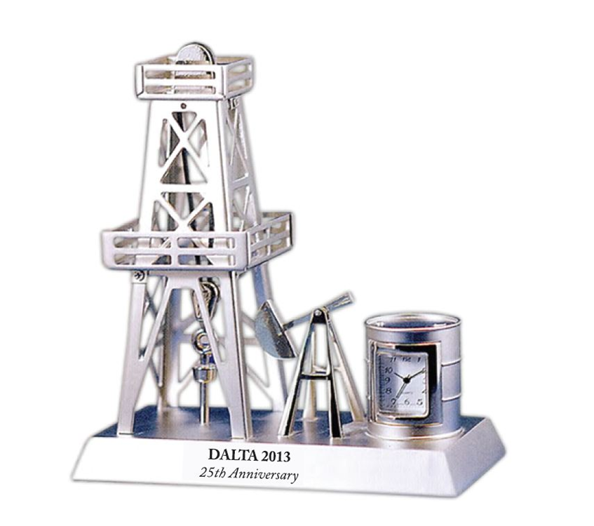

**\*\*\*\*\*\*\*\*\*\*A SPECIAL THANK YOU TO OUR SPONSORS\*\*\*\*\*\*\*\*\*\***

|  |  |
| --- | --- |
| [P2](http://www.p2energysolutions.com/)  <http://www.p2energysolutions.com/> | TAQA  Generously donated an iPad mini |